4/14/2023
PROJECT TEAM: Sumit Verma 0796783
Olabisi Fadahunsi 0801587
Prabhjot Kaur 0793969
Mahesh Reddy 0775855
Prediction of Inter-Vehicle Distance between Autonomous Vehicles
Using CNN, RNN and KNN.

Introduction

An autonomous car refers to a computer-controlled car that can guide itself, familiarize itself with surroundings, make decisions, and fully operate without any human interaction (Rasheed H & Sherali Zeadally, 2019). With the rapid growth in the scale of urban traffic and the standing increment of vehicles, car following (CF) has become the most common driving behavior in daily driving. It has been widely used in microscopic traffic simulation and autonomous driving (Li et al, 2022). Autonomous driving has been a focus of industry and academia in recent decades, with pledges for safety, convenience, and energy efficiency. According to Li et al (2022), for autonomous vehicles (AVs), safe and comfortable driving will increase passenger satisfaction and trust, minimize fuel consumption, and benefit auto owners financially. Poor CF performance will lead to traffic congestion and oscillation.
Many types and prototypes of autonomous cars have been manufactured by different manufacturers such as Tesla, Nissan, Hyundai, Kia, Chevrolet, and Ford. None of these have commercialized the dream of self-driving cars due to various challenges regarding safety, real-time nature data, speed, quality, heterogeneity, and volume. This is because a fully autonomous car should be able to function autonomously without human effort. The challenges of the autonomous vehicle include the unknown intentions of other road users; communication between vehicles and the road infrastructure is a possible approach to enhance awareness and enable cooperation (Gao et al, 2019).
According to Rasheed H & Sherali Zeadally (2019), the layered structure includes data acquisition performed by the hardware components, such as on-board and in-car sensors; short- and long-range radars; Light Detection and Ranging (LIDAR) tracking; and cameras and communication devices (transceivers). The data collected through these components are processed by the autonomous car’s central computer system, which is then used by the decision-support system. The decision-support system actuates the autonomous car. It is worth noting that situational awareness is realized through both short- and long-range imaging devices that include radar, LIDAR, and cameras.
The ability of autonomous cars is valid, but this is limited as most of the cars on the roads today are not autonomous which reduces the sensing ability of these autonomous vehicles. While some of these cars - Connected unintelligent vehicles (CUVs)—may be equipped with communication and Global Positioning System (GPS) devices, only low-level information is provided such as speed and position. Autonomous cars lack the ability to predict the intention of the CUV thereby leading to a traffic accident during maneuvering and changing of lanes.
In this project, a learning-based algorithm is developed to predict the safe following distance between two autonomous vehicles. The algorithm will be built using the KNN, CNN, and RNN to determine the safe following distance in an autonomous vehicle using the NGSIM dataset. By combining KNN, CNN, and RNN models, it is possible to improve the accuracy of inter-vehicle distance prediction by taking advantage of the strengths of both techniques. This can help autonomous vehicles to better anticipate the movements of other vehicles on the road and make safer driving decisions

Related Research

The rapid development of data-driven and artificial intelligence technology has received widespread attention in the field of transportation, and many researchers have provided machine learning methods to learn human driving habits.
Gao et al (2019) developed a learning-based algorithm to predict the CUV’s lane change intention and a car-following controller is designed by incorporating the lane-change intentions of the CUV. The estimation of CUV lane change intentions and the autonomous vehicle safety control strategy in a common and high-risk mixed traffic scenario. The CUV cuts into the lanes of adjacent autonomous vehicles in a non-cooperative manner. The libsvm toolbox in the MATLAB environment was used to model the driver’s lane-changing behavior and select the radial basis function as the kernel function of the SVM classifier.
Li et al (2022) utilized the following driving characteristics from real-world microscopic driving data and combines them with Deep Reinforcement Learning to realize autonomous following decision control. NGSIM data are widely used in the field of traffic flow, which played a vital role in the analysis of driving behavior at the tactical level, especially in research into vehicle interaction behavior in acceleration and lane change models. In their model, they proposed an agent-environment interaction model of an autonomous car-following decision-making model to provide automatic driving that is safe, effective, and comfortable. This was first done using the distribution of speed acceleration established according to NGSIM data, and the corresponding curve is fitted according to the 3σ boundary point of a normal distribution to realize the variable constraint of the agent’s actions. They proposed that enough individual drivers’ driving behaviors to be collected as historical data to further train the model to serve personalized driving.
Abdelmoghit Z et al, (2020), proposed an algorithm based on stereo vision for distance measurement using only web cameras, and the calculation formula contains simple terms based on web cameras criteria obtained by manual measurement (or noted in the cameras package). In the first step, the hypotheses are generated using cross-correlation after performing an edge detection method. In the second step, the generated hypotheses are verified by extracting the desired features using the third level of 2D-DWT and then classifying them using AdaBoost classifier.

Problem Objectives

The problem addressed by this topic is the need for accurate and reliable prediction of inter-vehicle distance in autonomous vehicles. For autonomous vehicles to operate safely and efficiently on the road, they must be able to accurately detect and track other vehicles and make decisions based on that information. However, the accuracy of traditional sensing methods such as LiDAR, radar, and cameras can be affected by factors such as weather conditions, occlusion, and sensor noise.
To improve the accuracy of inter-vehicle distance prediction, this topic proposes the use of machine learning techniques, specifically CNNs and RNNs, to analyze sensor data and make predictions in real-time. The problem is to develop a model that can accurately predict the distance between the autonomous vehicle and other vehicles on the road, even in challenging conditions. This will require training the model on large datasets of sensor data and optimizing its performance to achieve the highest possible accuracy. The goal is to develop a reliable and effective inter-vehicle distance prediction system that can improve the safety and performance of autonomous vehicles on the road.
Convolutional neural networks (CNNs) and recurrent neural networks are combined to increase the accuracy of vehicle distance prediction in autonomous vehicles and solve the limitations of modal sensing technologies (RNNs). We can identify and track other vehicles on the road by using a CNN to process visual data from cameras. Based on their past actions, the RNN may use this information to predict where these cars will be in the future.
Three components of this research will be the focus of our upcoming investigation.
- To keep the inter-vehicle distance within a more appropriate range, road traffic efficiency will first be considered.
- To provide users with more options, our second goal is to characterize driving behaviors more thoroughly.
- Finally, to make the suggested model more acceptable and useful, we intend to create the driver model in conjunction with the lower controller's executive capability.
The multiple objectives include minimizing the following:
- the error between actual inter-vehicle distance and desired inter-vehicle distance to reflect driving styles.
- the relative speed to the leading vehicle to maintain the following behavior.
- the acceleration and the jerk to ensure comfort. In addition, constraints can be integrated into the driving style while ensuring safety.

Data Source

For this project, we are currently exploring two options. We can obtain the data manually by taking images or also use the NGSIM dataset currently made available.
- The autonomous car alone has sensors and cameras that can collect data about its surroundings, such as other vehicles, pedestrians, and road conditions. The location, route, and traffic conditions of the car can be determined using GPS and mapping data.
- The NGSIM dataset can be used to evaluate our accuracy. Accurate datasets are difficult to find several data online. We did, however, locate some.
https://datahub.transportation.gov/stories/s/Next-Generation-Simulation-NGSIM-Open-Data/i5zb-xe34/

Car-Following Distance Calculation Model

Progress report

The following work has been done so far on this project work;

Exploratory Data Analysis (EDA):

  - For this project, we choose the NGISM dataset for our model. Due to the complexity of the dataset, we went ahead to the first step with the EDA.
  - Performed several data manipulation tasks on the pandas Data Frame that contained data on the behavior of vehicles in highway traffic.

Cleaning of Dataset:

  - Removed duplicate rows using the remove_duplicates function and converted certain columns from feet to meters using the convert_feet_to_metre function.
  - We also created new columns with NaN values using the assign method and mapped values in the v_Class column to new values using the map method. Finally, I used the Filter_highways function to filter the original DataFrame into two separate dataFrames based on the location of the highways. These actions helped prepare the data for further analysis and gain insights in order to the behavior of vehicles on highways.
  - Several functions have been defined to process and filter a panda DataFrame containing data on traffic flow. The filter_vehicle_classes() function takes the DataFrame and returns sets of vehicle IDs for each vehicle class. The preceding_vehicle() function maps each vehicle's preceding vehicle to its class and creates a new column with the vehicle combination.
  - The preced_vehicle_length() function calculates the average length of each motor vehicle and assigns it to its preceding vehicle. Finally, the change_front_to_back() function calculates the rear-to-front space headway and front-to-rear time headway for each vehicle. The functions are applied to separate DataFrames created by filtering the original Data Frame based on the highways US-101 and I-80.
  - The first function, called "transforming_map_lead_Vehicle", seems to perform a series of operations to identify the lead vehicle for each vehicle, calculate relevant attributes of the lead vehicle, and merge this information with the original Data Frame. To accomplish this, the function first creates a new Data Frame called "Lane_check" that contains each vehicle's ID and the lane it is in. It then drops any duplicate rows and groups the Data Frame by vehicle ID to count the number of lanes each vehicle traverses.
  - Went ahead to take only 4 lanes, and we are assuming the 5,6,7,8 lanes as exit roads from the highway or ramps road. After this, we made two functions find_following_lane_change_pairs and find_preceding_lane_change_pairs, are designed to identify pairs of vehicles that have changed lanes. The find_following_lane_change_pairs function identifies pairs based on the following vehicle, whereas the find_preceding_lane_change_pairs function identifies pairs based on the preceding vehicle. Both functions return a list of lane change pairs. The input data for these functions is a data frame that contains information about each vehicle's lane changes, including their preceding and following vehicles, and their vehicle ID. These functions are useful for analyzing lane-changing behavior on highways or other roadways.
  - The filter_records_for_model function takes a pandas data frame and filters out rows based on certain criteria. First, it removes vehicles with multiple lengths and classes for the same vehicle ID. Next, it removes vehicles with a total car following time of less than 30 seconds, time headway of less than 5 seconds, and those on ramps. It also removes vehicles that change lanes within the first and last 5 seconds. The function prints a summary of the removed rows for each lane and returns the filtered data frame.

Baseline model:

  - made a random forest regressor model for just checking our initial model. A data frame df, a split ratio split, a Boolean neural indicating whether the split is for neural network training, and a random seed are all inputs for the train_test_pair function. Based on the split ratio and the neural flag, it divides the data frame into three segments: train, validation, and test. A portion of the test set is used for validation if the neural is True. The three data frames train_df, val_df, and test_df then returned by the function. The lead-Front_Pair column's unique values are used to split the data, and the split is then randomized using the seed option.
  - After deploying our initial model, we received an overfitting rf.score of 0.9999967. We are aware that overfitting can teach us how to create the optimal model. We examined where we were falling short. We discovered that there was an excessive amount of correlation between the columns, so we created a heat map to show which columns have the highest correlation.

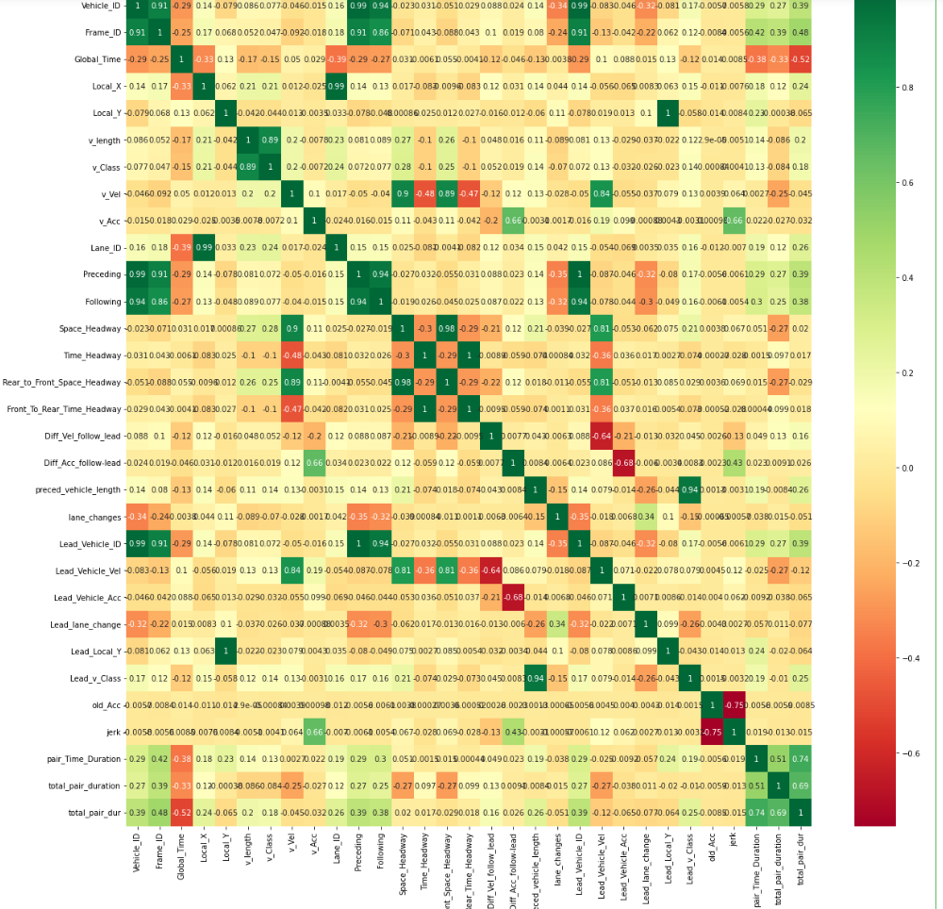

  - This heat map makes it very evident that there was an excessive amount of correlation between the columns. Therefore, made the decision to only use important variables in our model, and we selected the following columns: Lead_v_Class, Diff_Vel_follow_Lead, v_Vel, v_Acc, v_Class, and Rear-to-Front-Space-Headway.

Feature Selections:

  - After our selected columns, we got a good rf.score = 0.876, indicating that ffeature selection worked

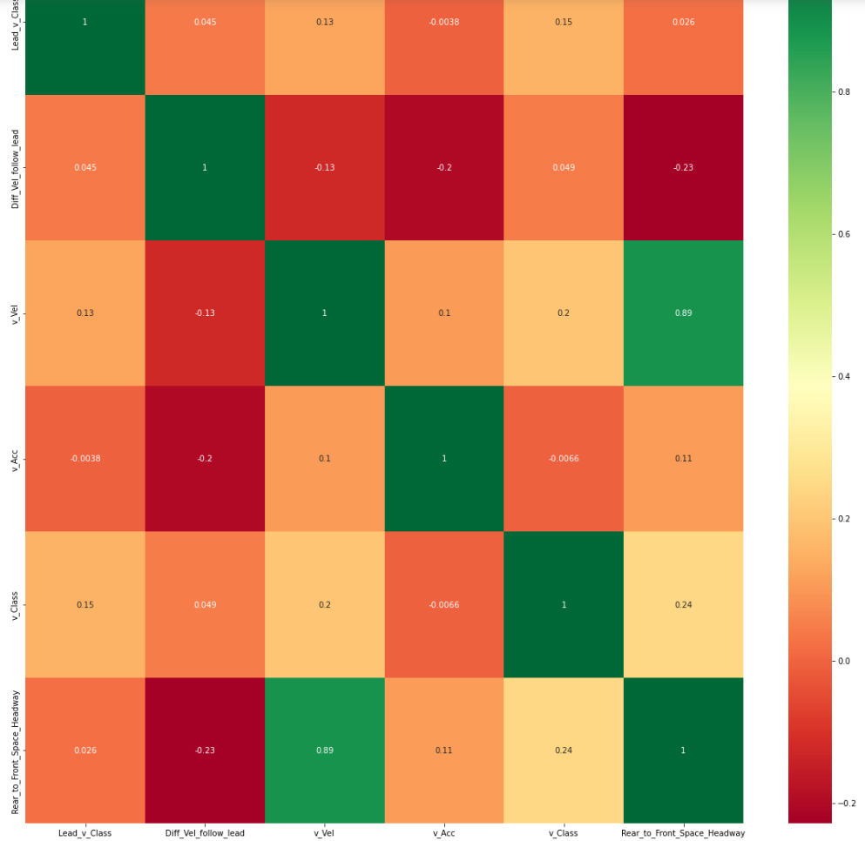

- After Feature Selection, we went ahead to tune the hyperparameter for a better r2.score, however, we failed to make it better and we will look into it deeply in the next semester.

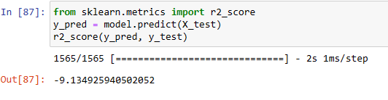

Ethical Consideration

Based on the NGSIM open data, the following five ethical issues with autonomous following cars are related to permission, clarity, consequences, control, and consistency:
- Consent: The data in use for this project work is open source data that is open to all for analysis. Moreso, appropriate consent will be requested from the stakeholders as it is critical to gain informed consent from passengers before autonomous following cars collect and use any of their data. The types of information being gathered, how they will be utilized, and who will have access to them must all be adequately disclosed to passengers. This enables people to decide how to handle their privacy and personal data with knowledge.

- Clarity: The objectives of the project have been stated clearly in the project objectives session and there will no diversion in this regard. It is important to make sure that passengers understand how the technology functions, how it makes judgments, and what they can and cannot do while inside the car. This guarantees that the technology is safe and used by passengers.

- Consequences: After perceiving the environment, the car needs to get environmental awareness of its surroundings, which aids in developing the movement trajectory followed by navigation. Data will be collected by the vehicle and then used for navigation. It is crucial to consider the ethical issues raised by autonomous following vehicles. It is critical to consider the potential effects of these cars on society, including job displacement, modifications to the transportation sector, and environmental effects.

- Control: Contact phone and email will be made available to passengers so that they are aware of the capabilities and restrictions of autonomous cars requires clear communication in the case user has any issue with their data. Users can decide to the technology must be under the passengers' control, and they must be able to step in when the vehicle's judgments may not be in line with their preferences. This guarantees that users of autonomous following cars can keep their safety and autonomy.

- Consistency: Trust is key in any business or endeavor, hence based on our track record in other projects, we have given customers assurance that their information will be used anonymized and pseudonymized. Regardless of the circumstance or the people involved, autonomous following cars must make decisions consistently and safely. This makes sure that everyone is treated equally and impartially by technology.

Conclusion and future work

Overall, the use of KNN, CNN, and RNN to improve modal sensing in the prediction of inter-vehicle distance in autonomous vehicles will have a positive impact on various stakeholders, improving safety, efficiency, and comfort in the transportation sector.
In the next semester, the team will go ahead to create three models: CNN, RNN, and KNN. When this is done, we will go ahead to compare all the models and choose the best one. Planning to predict all models and then go ahead with the deployment of the model.

References

Abdelmoghit Z et al, 2020. Distance measurement system for autonomous vehicles using stereo camera. ScienceDirect. Available at: Distance measurement system for autonomous vehicles using stereo camera - ScienceDirect
Gao et al. 2019. Conditional Artificial Potential Field-Based Autonomous Vehicle Safety Control with Interference of Lane Changing in Mixed Traffic Scenario. Available at: Conditional Artificial Potential Field-Based Autonomous Vehicle Safety Control with Interference of Lane Changing in Mixed Traffic Scenario - ProQuest. Accessed 11th April, 2023.
Li et al. 2022. A Decision-Making Strategy for Car Following Based on Naturalist Driving Data via Deep Reinforcement Learning. Available at: A Decision-Making Strategy for Car Following Based on Naturalist Driving Data via Deep Reinforcement Learning - ProQuest Accessed 12th April, 2023.
Rasheed Hussain & Sherali Zeadally, 2019. Autonomous Cars: Research Results, Issues, and Future Challenges. Available at: Autonomous Cars: Research Results, Issues, and Future Challenges | IEEE Journals & Magazine | IEEE Xplore (oclc.org) Accessed 11th April, 2023.
S. Lefèvre, A. Carvalho and F. Borrelli, "A Learning-Based Framework for Velocity Control in Autonomous Driving," in IEEE Transactions on Automation Science and Engineering, vol. 13, no. 1, pp. 32-42, Jan. 2016, doi: 10.1109/TASE.2015.2498192.
Carey, N., & Lienert, P. (2022). Truly autonomous cars may be impossible without helpful human touch. Reuters. https://www.reuters.com/technology/truly-autonomous-cars-may-be-impossible-without-helpful-human-touch-2022-09-12/
Autonomous and Electric Vehicles: The Future of Mobility. (55083, May 23). Wevolver. https://www.wevolver.com/article/autonomous-and-electric-vehicles-the-future-of-mobility
Gerard Gibbs & Huamin Jia (2021) . Obstacle Detection with Ultrasonic Sensors and Signal Analysis Metrics https://www.sciencedirect.com/science/article/pii/S2352146517311031?via%3Dihub
Yeruva, V. (2022). Autonomous Vehicles And Their Impact On The Economy. Forbes.
https://www.forbes.com/sites/forbestechcouncil/2022/02/14/autonomous-vehicles-and-their-impact-on-the-economy/?sh=7f2f8ac060de
Takens, F. (1981) Detecting Strange Attractors in Turbulence. In Rand, D.A. and Young, L.-S., Eds., Dynamical Systems and Turbulence, Lecture Notes in Mathematics, Vol. 898, 366-381. - References - Scientific Research Publishing. (n.d.).
https://www.scirp.org/(S(lz5mqp453edsnp55rrgjct55))/reference/ReferencesPapers.aspx?ReferenceID=2173085

